## Normal Form Analysis:

Requirement: 3NF

A relation is in 3NF, if it satisfies 2NF (and in turn 1NF) and no non-prime attributes are transitively dependent on any candidate key.

All relations satisfy 1NF since there are no multivalued attributes nor nested relations.

All relations satisfy 2NF since there are no non-prime attributes which are only partially dependent on any candidate key.

All relations are in 3NF.

For example, violation of 2NF is avoided in “OrderDetails“ by not specifying the “Price“ (“BasePrice“) in the “OrderDetails“, which would be functionally dependent on the partial key “flavor_id”.

There is no violation of 3NF in relation “Warehouses”. “Capacity” is not transitively dependent on the “warehouse_id” because “address” itself is a candidate key, therefore there is no problem.

Contents

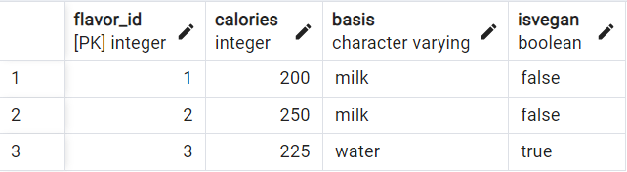

Flavors

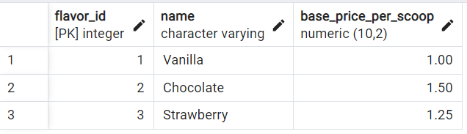

IceCreamVendors

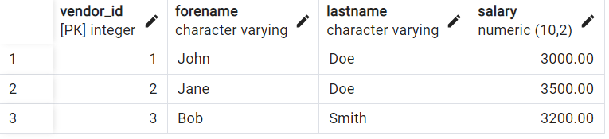

Neighborhoods

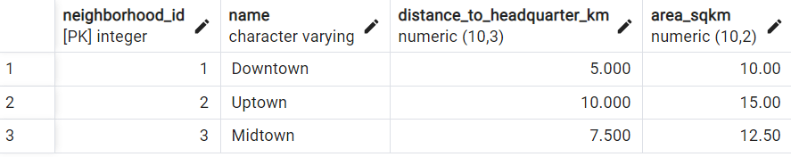

Orderdetails

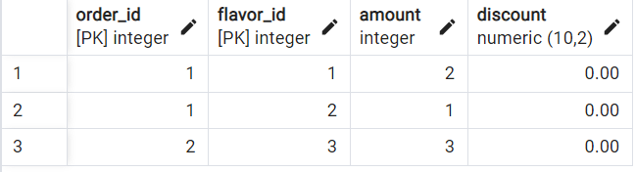

Orders

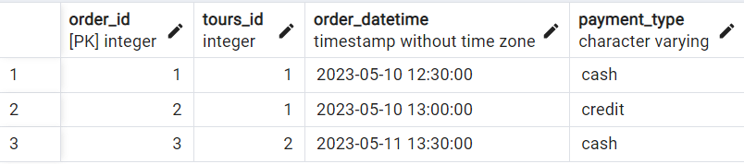

Tours

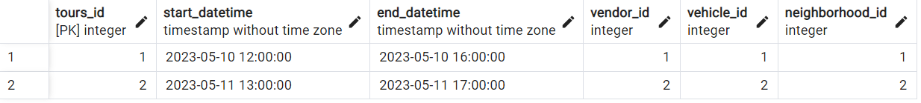

Vehicles

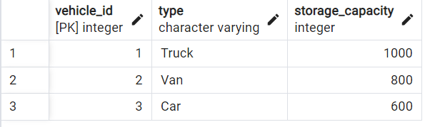

VehiclesStoreFlavours

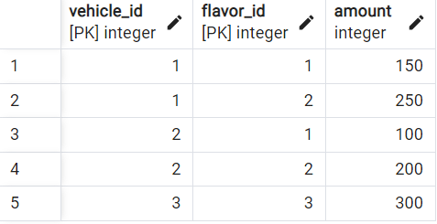

Warehouses

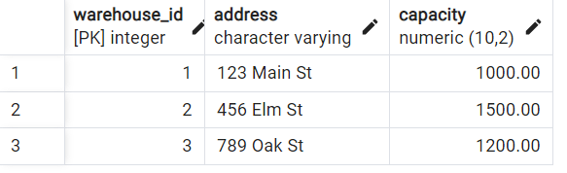

WarehoursesStoreFlavours

